HS2-004 Dynamic Risk Assessment for Riverfly kick sampling activities.
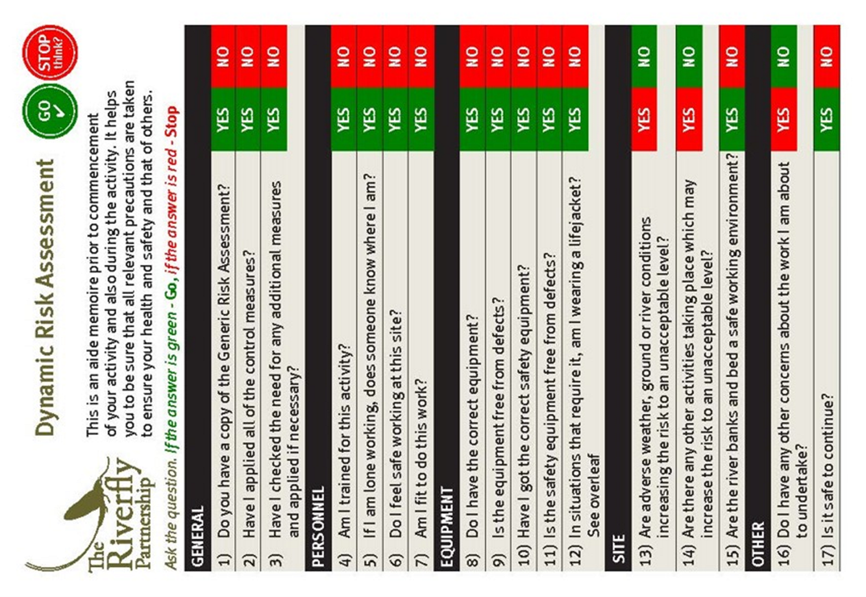
For further information on The Riverfly Partnership visit www.riverflies.org

